**MISY 5300**

**Assignment 6**

**USE: Oracle-SQL**

**Total Points: 20**

Instructions:

Log into LiveSQL Workspace

**Refer to the Oracle SQL Part 2 examples and the E-R diagram before creating the queries below.**

**Number each query you create. Take a screen shot of your syntax, then run the query and take a screen shot of the output, so you’ll be submitting two screen shots for each query. Number each screen shot, such as 1A and 1B for the first query, 2A, 2B for the second query, etc.** **Make sure each screen shot is large enough to be easily read and give its number.**

You’ll be using the Employees and Departments tables for the queries below:

1. Create a query that will give a unique listing of all job numbers that are in department 80. Include the location numbers of the department in the output.

1. Create a query to display the manager number and the salary of the lowest paid employee for that manager. Exclude anyone whose manager is not known. Exclude any groups where the minimum salary is $6,000 or less. Sort the output in descending order of salary.

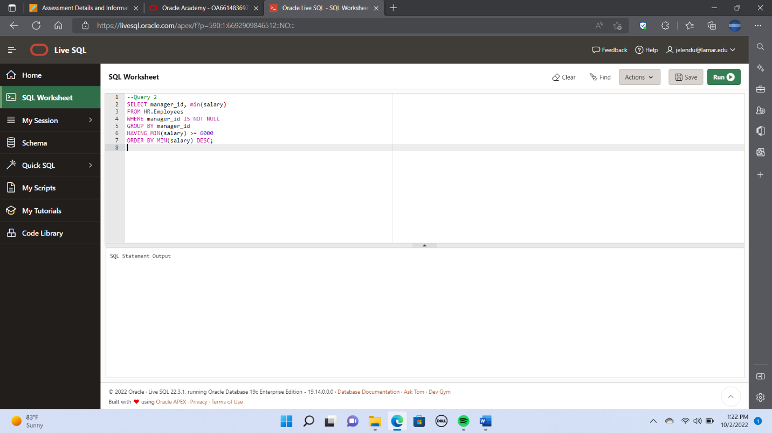

1. Create a query to display the employee numbers and last names of all employees who earn more than the average salary. Sort the results in ascending order of salary.

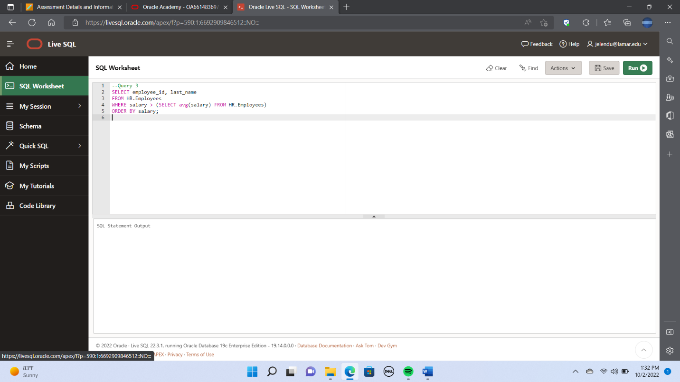

1. Create a query to display the last name and salary of every employee who reports to King. A screenshot of a computer

   Description automatically generated

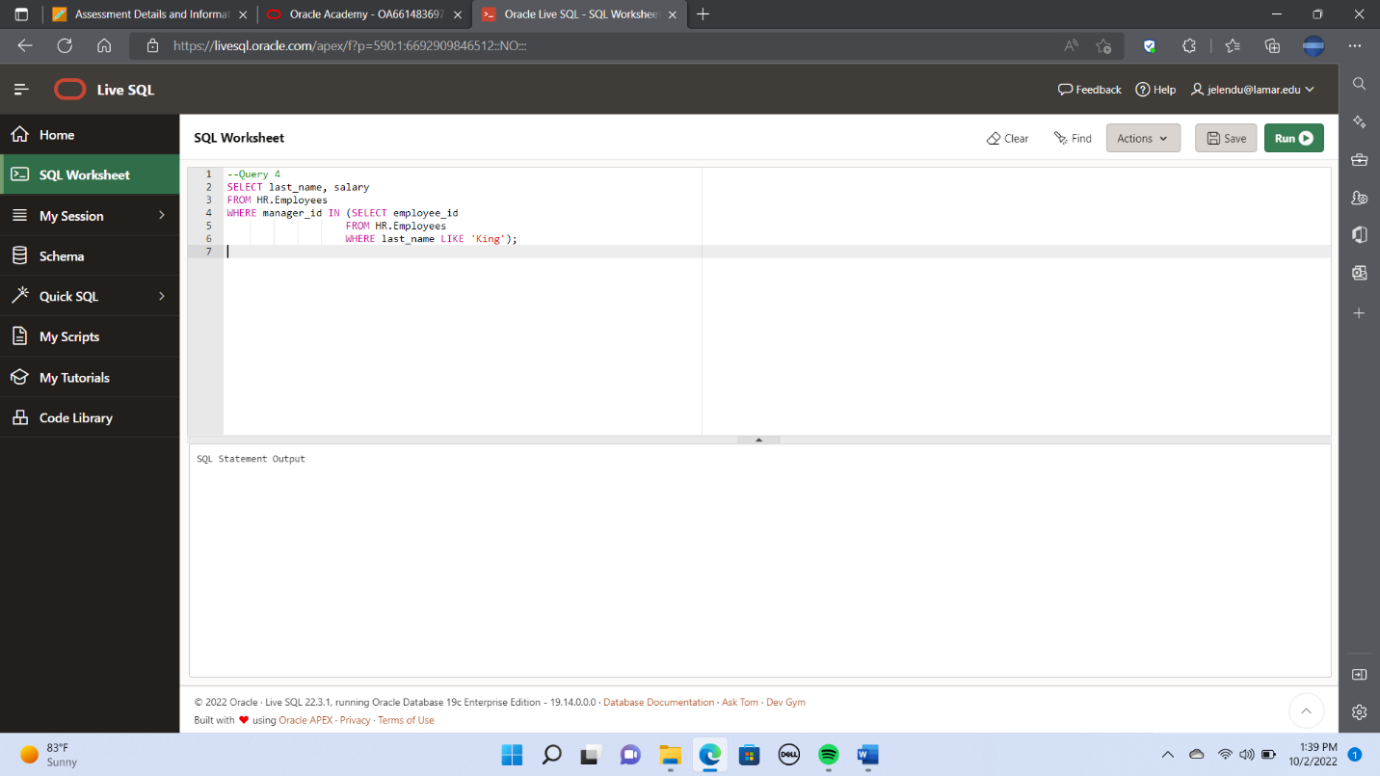

1. Create a query to display the employee numbers, last names, and salaries of all employees who earn more than the average salary and who work in a department with any employee with a **u**in their last name. 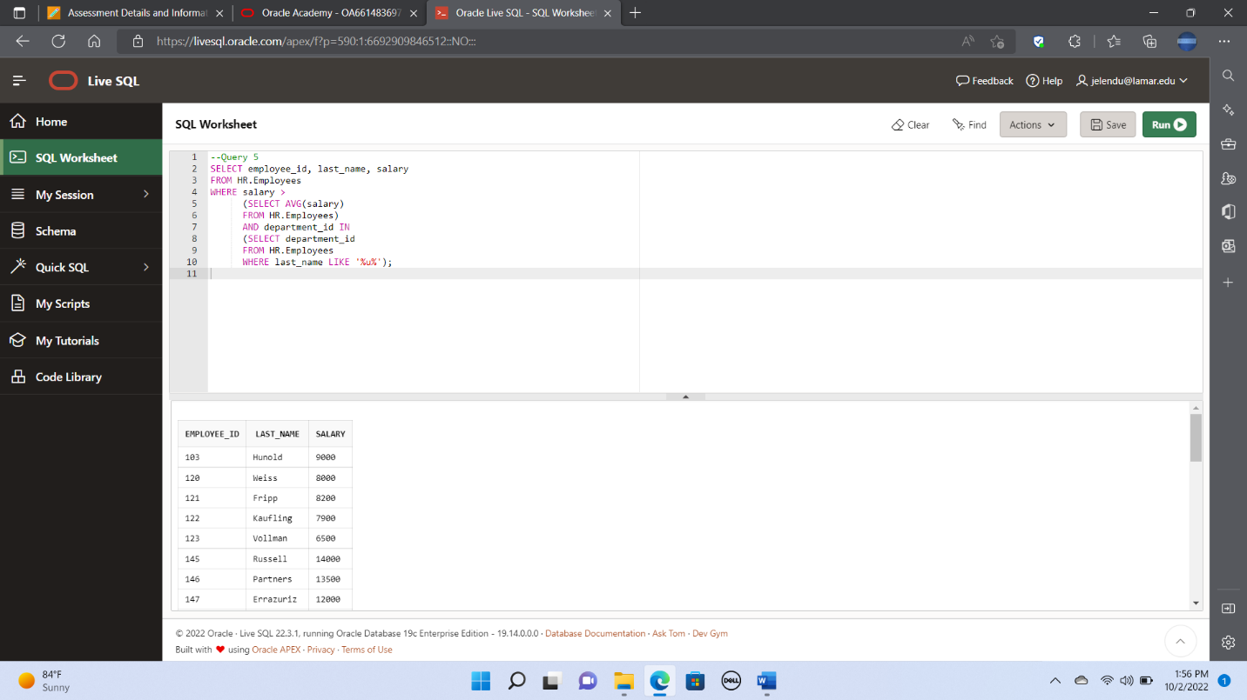

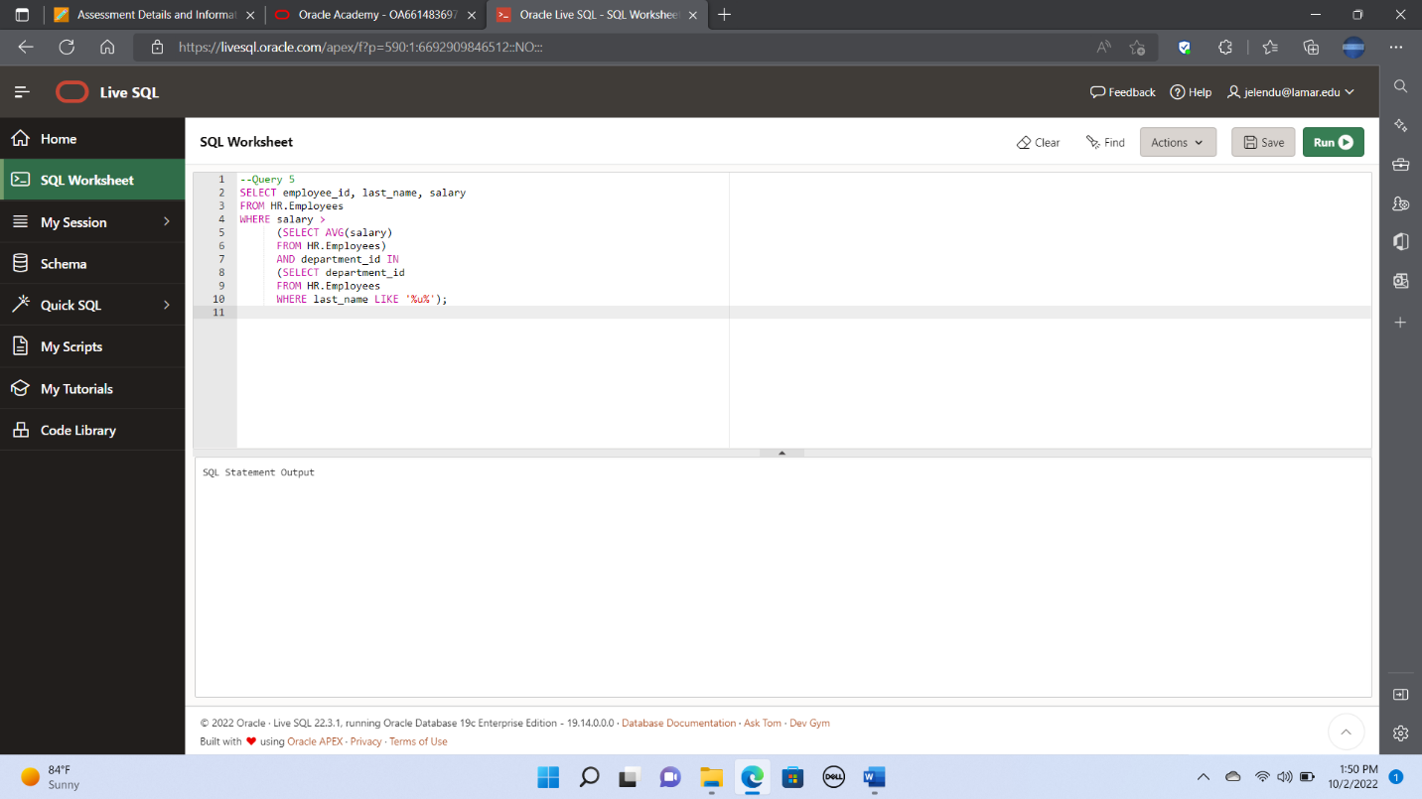

1. Create the EMPLOYEESXX (replace XX with your initials) table based on the structure (column data type, data size) of the original EMPLOYEES table. Include only the EMPLOYEE_ID, LAST_NAME, SALARY, and DEPARTMENT_ID columns. Name the columns in your new table ID, LAST_NAME, SALARY, and DEPT_ID, respectively.

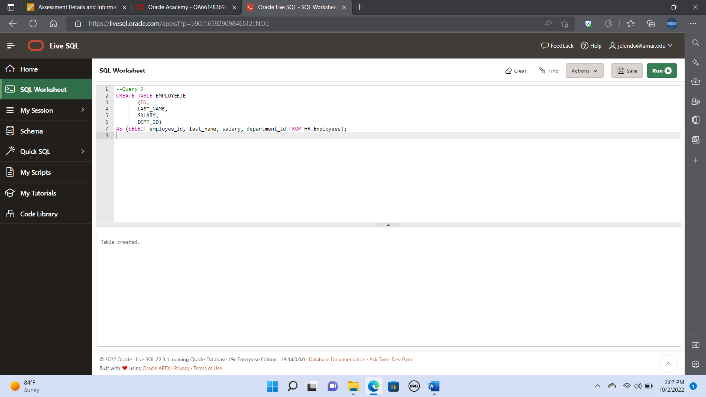

1. Create a query that will drop the LAST_NAME column from the EMPLOYEESXX table. Confirm your modification by checking the description of the table. A screenshot of a computer

   Description automatically generated

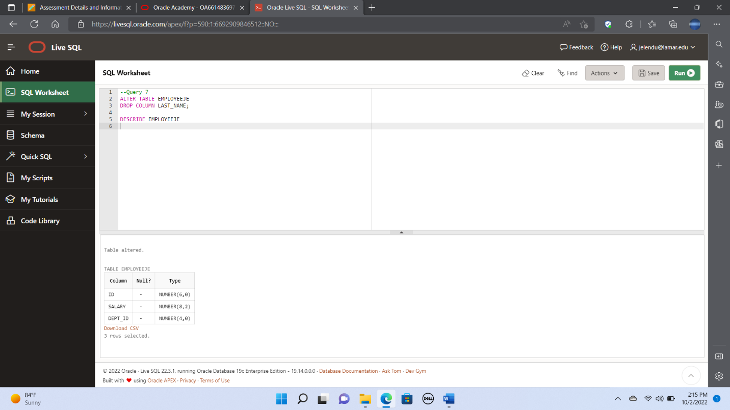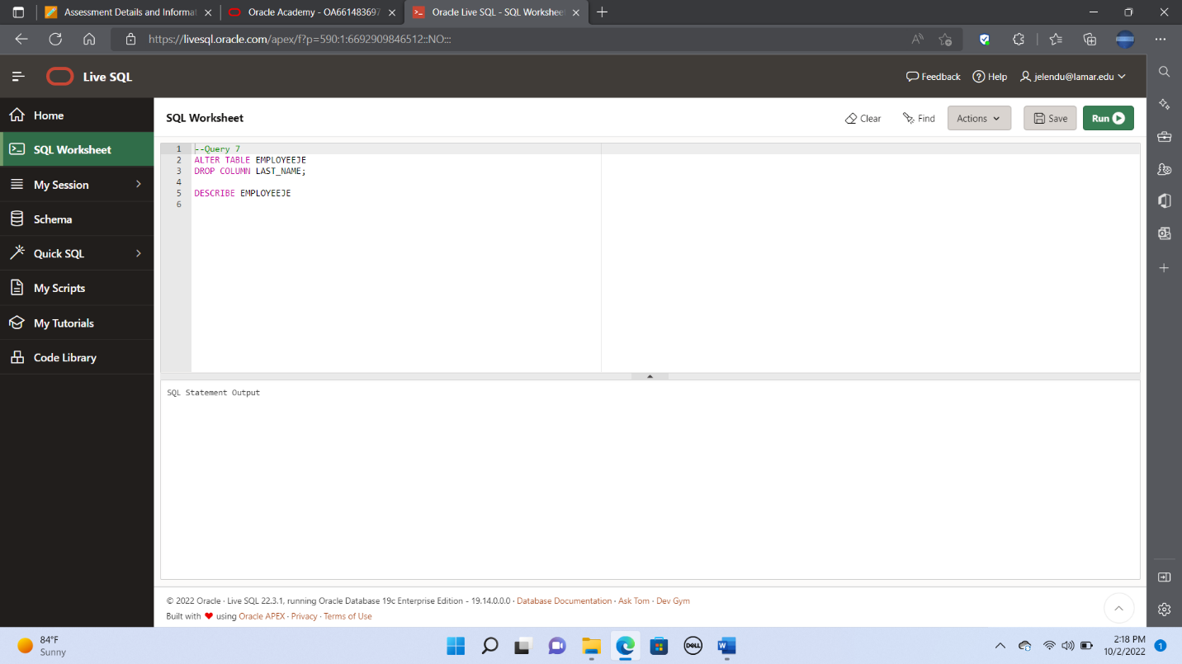

1. Create the MY_EMPLOYEEXX (add your initials in place of XX) table. Then Insert data into the table from the following sample data. Confirm your addition to the table.

|  |  |  |  |
| --- | --- | --- | --- |
| ID | LAST_NAME | USERID | SALARY |
| 1 | Patel | rpatel | 895 |
| 2 | Dancs | bdancs | 860 |
| 3 | Biri | bbiri | 1100 |
| 4 | Newman | cnewman | 750 |

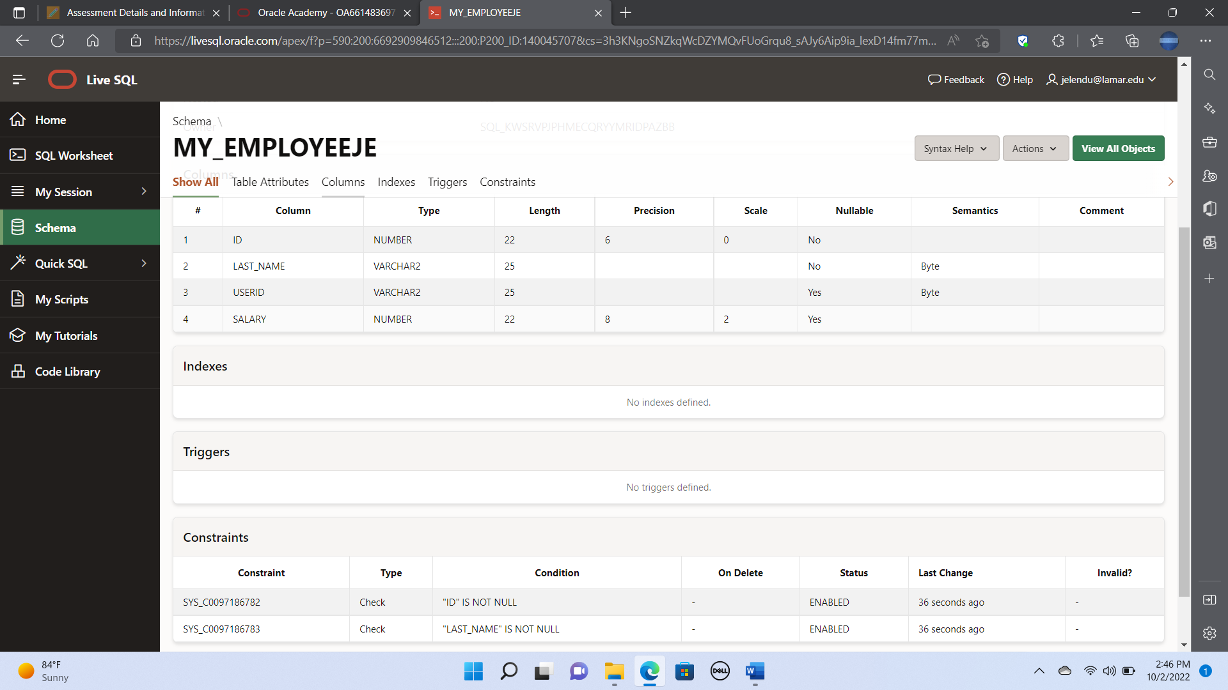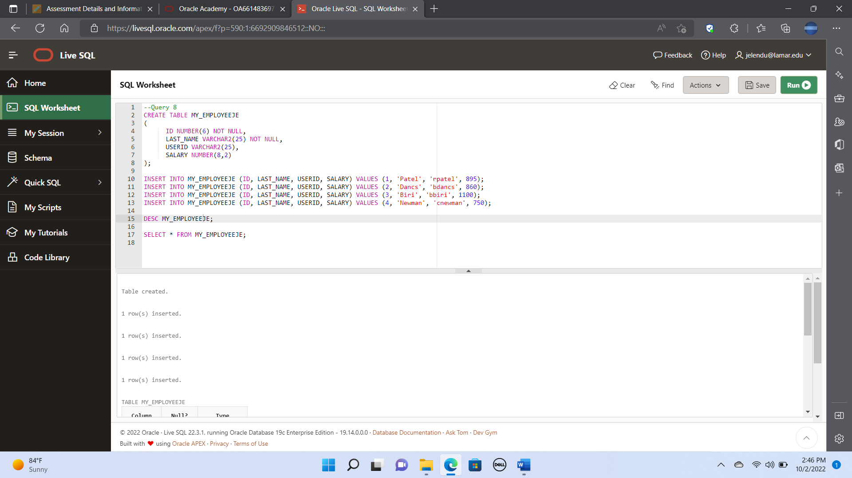

1. Create a query that will change the last name of employee 3 in the MY_EMPLOYEEXX table to Drexler, and change the salary to 1000 for all employees with a salary less than 900. Verify your changes to the table.

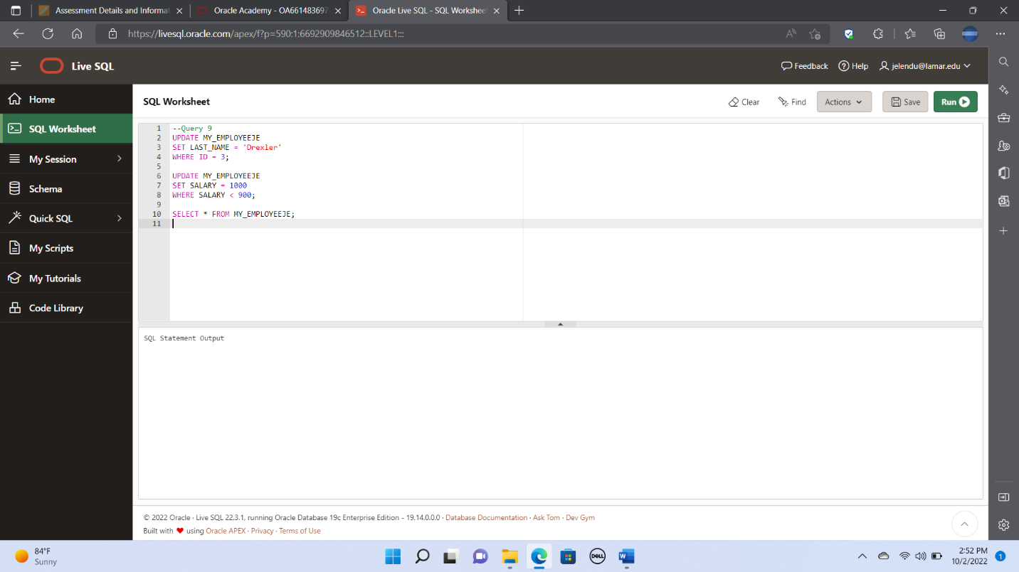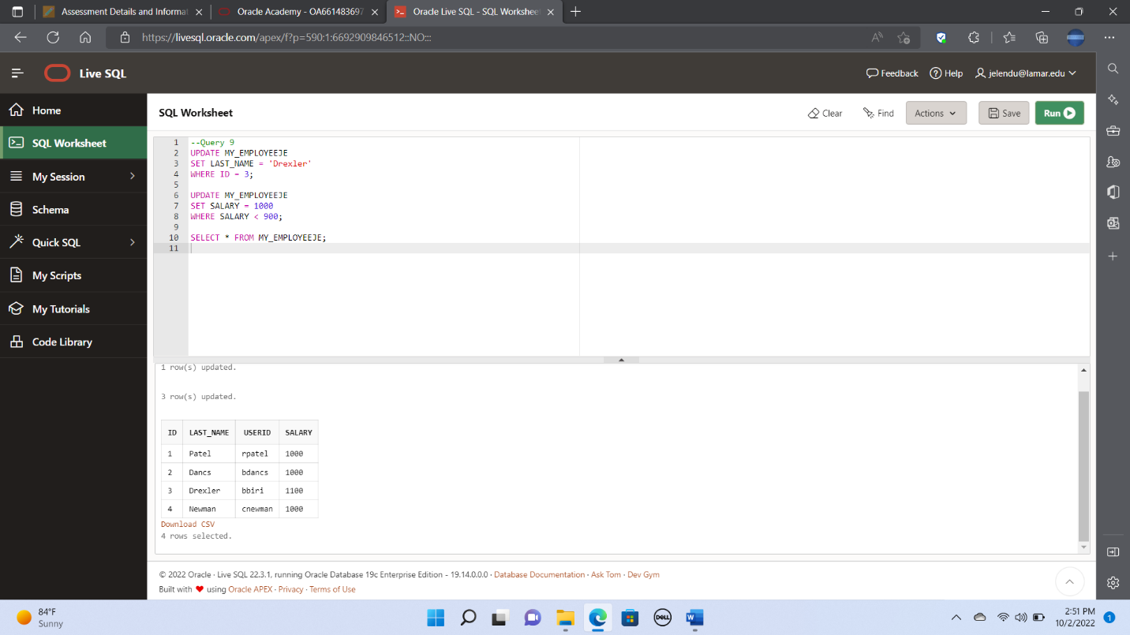

10. Create a query that will add a PRIMARY KEY constraint to the MY_EMPLOYEEXX

table on the ID column. Name the constraint my_empXX_id_pk.

